1. Publish Preview Report—This may be expected, but the left navigation is not showing fully.

QA version:

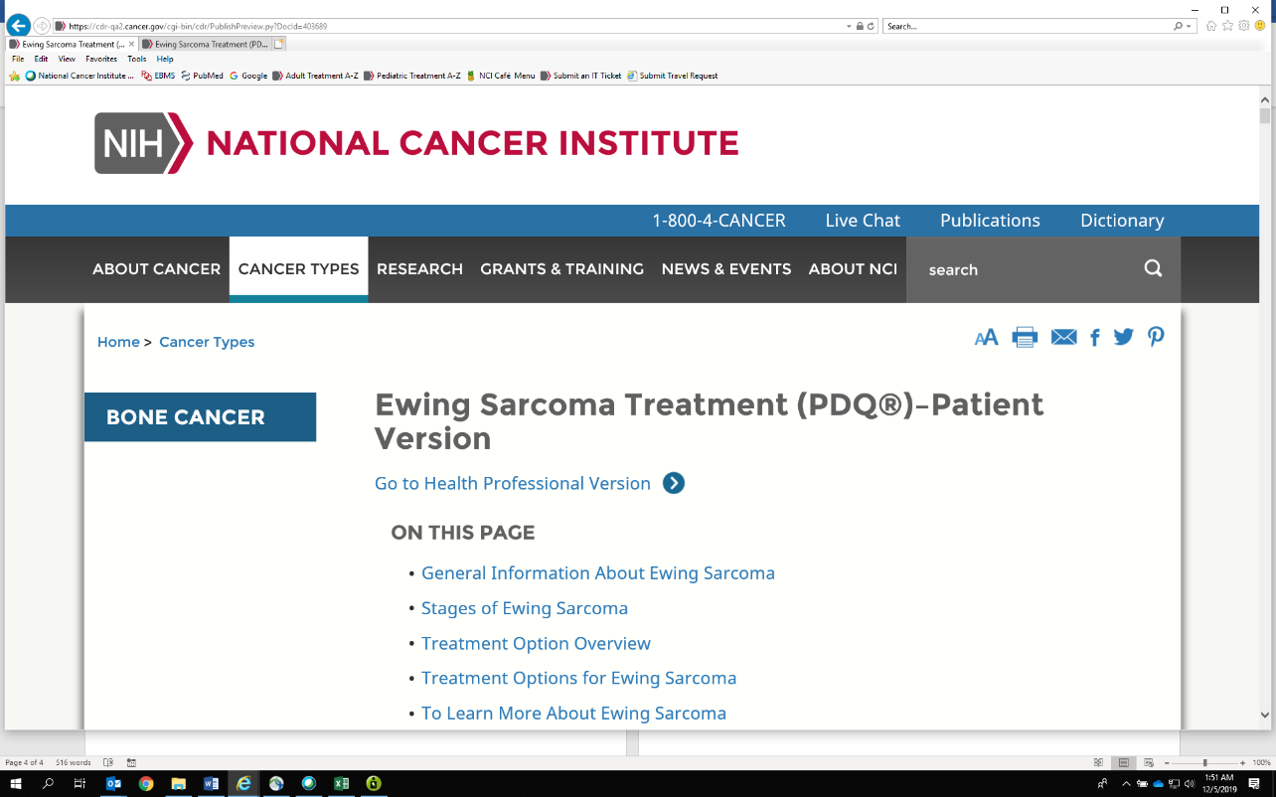

Prod version:

